

PiaoConnect
An Integrated Web-Based Membership, Attendance, Event, and Resource Management System for Barangay Piao

A Capstone Project
Presented to the Faculty of the
College of Computer Studies
DMC College Foundation, Inc.

In partial fulfillment of the
Requirements for the Degree of
Bachelor of Science in Information Technology

ALISWAG, ZEIN BERNARD A.
GODITO, LITO ARTHON R.
MARABULAS, LYKA MAE A.

Mrs. Maria Dara C. Saquin-Woo
Capstone Adviser

CHAPTER I
THE PROBLEM AND ITS BACKGROUND

Introduction
The rapid advancement of information technology has transformed the way organizations manage information and deliver public services. Government institutions increasingly adopt digital systems to improve operational efficiency, data accuracy, transparency, and service delivery, and at the local government level this transformation enables faster processing of records, better information management, and more efficient communication with the public. Bringula et al. [1] emphasized that community-level e-government systems improve the delivery of barangay services by providing web-based platforms for record management, announcements, and other public services, while Aliling et al. [2] found that digitalizing barangay administrative processes through an electronic information management system enhanced the efficiency, accessibility, and reliability of government services.
Barangays play a vital role in delivering basic government services and maintaining records of residents and community activities. One of their regular responsibilities is monitoring attendance during assemblies, meetings, seminars, and other barangay events, yet in many barangays this is still done manually using attendance sheets and logbooks. Manual record-keeping makes information retrieval time-consuming and increases the likelihood of misplaced records, duplicate entries, and human error, ultimately reducing the efficiency of administrative work and delaying service delivery. Agripa and Astillero [3] found that QR code-based attendance systems improve the accuracy, speed, and reliability of attendance recording by automating registration and reducing human error, suggesting that a digital attendance management system could help barangays streamline operations and maintain more accurate records.
This is consistent with the broader body of research on digital attendance and record management reviewed in this study: systems that replace manual, paper-based recording with QR-code scanning and centralized databases reduce duplication of records, speed up registration, and lower the likelihood of human error, while automated reporting and role-based access controls further improve the efficiency and security of record management.
Despite these advancements, Barangay Piao, Roxas, Zamboanga del Norte, still manages attendance and membership records manually using paper forms and folders. Searching for resident information requires checking physical records, making the process slow and prone to error, and during barangay events, residents manually sign attendance sheets, resulting in long queues and delayed registration. These persistent challenges highlight the need for a computerized system that can improve record management, reduce manual work, and provide faster access to information.
Therefore, this study proposes the development of PiaoConnect: An Integrated Web-Based Membership, Attendance, Event, and Resource Management System for Barangay Piao. The proposed system will utilize QR code technology and a centralized database to automate attendance recording, manage memberships, post events, send notifications, generate printable reports, and provide secure and organized digital records for barangay staff and residents.

Statement of the Problem
This study aims to address the problems encountered in the manual attendance and membership management process of Barangay Piao, Roxas, Zamboanga del Norte.
Specifically, this study seeks to answer the following questions:
- What are the problems encountered in the existing manual attendance and membership management process in Barangay Piao?
- What features should the proposed Membership, Attendance, Event, and Resource Management System include to address the identified problems?
- How can the proposed system improve the management of attendance, membership records, event announcements, and notifications?
- What is the level of acceptability of the developed system in terms of:
4.1 Functionality
4.2 Usability
4.3 Reliability
4.4 Security
4.5 Efficiency

Objectives of the Study
The general objective of this study is to design and develop PiaoConnect: Membership, Attendance, Event, and Resource Management System for Barangay Piao, Roxas, Zamboanga del Norte.
Specifically, this study aims to:
- Determine the problems encountered in the current manual attendance and membership management process.
- Design the system based on the identified requirements of the barangay.
- Develop a membership attendance management system with:
3.1 QR code generation
3.2 QR code attendance scanning
3.3 Resident management
3.4 Membership management
3.5 Event posting
3.6 Notification management
3.7 Attendance monitoring
3.8 Printable reports
3.9 Event budget tracking
3.10 Multi-language interface (Filipino/Tagalog and Bisaya)
3.11 Automated post-event feedback collection
3.12 Barangay inventory management
- Evaluate the developed system in terms of:
4.1 Functionality
4.2 Usability
4.3 Reliability
4.4 Security
4.5 Efficiency

Scope and Delimitation
This study covers the design, development, implementation, and evaluation of PiaoConnect: Membership, Attendance, Event, and Resource Management System for Barangay Piao, Roxas, Zamboanga del Norte. The system provides a centralized database that enables barangay staff to store, access, and update resident information efficiently. It includes features such as resident management, membership management, QR code generation for members, QR code attendance scanning, event posting, notification management, attendance monitoring, printable reports, event budget tracking, automated post-event feedback collection, barangay inventory management, a multi-language interface (Filipino/Tagalog and Bisaya), and a search function for faster record retrieval.
The system is designed for two types of users: barangay staff and barangay residents. Barangay staff can manage resident information, memberships, attendance records, events, notifications, event budgets, and barangay inventory, and generate printable attendance and membership reports, while barangay residents can access their profiles, view their memberships, monitor their attendance records, receive notifications, submit feedback after each event, and use their assigned QR codes during barangay events. Residents and staff may also switch the system's interface between Filipino/Tagalog, Bisaya, and English.
The study focuses on evaluating the effectiveness and acceptability of the system in improving attendance and membership management in Barangay Piao.
The study is limited to the operational needs of Barangay Piao and is intended primarily for membership, attendance, and event management, extended to include event-level budget tracking and a barangay asset inventory. It does not include full financial accounting, payroll processing, procurement, or other administrative services unrelated to membership, attendance, and event management.
For this term, development is limited to Increments 1 through 3 of the prototyping schedule in Table 2: resident and membership management, QR code attendance, and event and notification management. Increments 4 and 5, comprising event budget and inventory tracking, automated post-event feedback, printable reports, and multi-language support, are designed and scoped in this proposal but are targeted for completion and evaluation in Capstone 2.
Furthermore, the findings of the study are based on the evaluation conducted in Barangay Piao and may not be applicable to other barangays with different organizational structures, larger populations, or different record management practices.

Significance of the Study
The results of this study will benefit the following:
Barangay Staff. The proposed system will help barangay staff manage resident information, memberships, attendance records, events, event budgets, barangay inventory, and notifications more efficiently. It will reduce the time required for manual recording, minimize errors in record management, improve data retrieval, provide clearer visibility into event expenses and barangay assets, and simplify the generation of attendance and membership reports.
Barangay Residents. The system will provide residents with a more convenient and efficient way of participating in barangay activities. Residents will be able to access their membership information, view attendance records, receive event announcements and notifications, submit feedback after attending an event, and use QR codes for faster attendance registration during barangay events, all through an interface available in Filipino/Tagalog, Bisaya, or English.
Barangay Piao. The implementation of the system will contribute to the modernization of barangay operations by improving the accuracy, organization, and security of attendance and membership records, and by giving officials clearer visibility into event budgets, barangay assets, and resident feedback. It will support better record management, enhance communication between barangay staff and residents in the language they are most comfortable with, and promote more efficient delivery of community services.
Future Researchers. This study may serve as a reference for future researchers who plan to develop, enhance, or evaluate attendance management systems, membership management systems, or other community-based information systems. It may also provide useful insights into the application of QR code technology and web-based systems in local government units and community organizations.

Definition of Terms
Attendance Monitoring. The process of recording and tracking members' participation in barangay events using QR code scanning.
Automated Feedback. A short survey automatically sent to a resident after an event they attended, used to collect ratings and comments for barangay staff to review.
Barangay Inventory. The system's record of barangay-owned assets, supplies, and equipment, including their quantity, condition, and location.
Centralized Database. The digital storage where resident information, attendance records, memberships, and events are securely stored.
Event Budget Tracking. The recording and monitoring of the approved budget and actual expenses of a barangay event within the system.
Member. A registered resident of Barangay Piao who has an account in the system and belongs to one or more barangay memberships.
Membership, Attendance, Event, and Resource Management System. The computerized system developed in this study for managing resident memberships, attendance records, events, notifications, event budgets, and barangay inventory in Barangay Piao.
Multi-language Support. The system's ability to display its interface in Filipino/Tagalog, Bisaya, or English, based on the user's preference.
QR Code. A machine-readable code generated by the system that contains a member's identification information for attendance scanning.
Staff. Authorized barangay personnel responsible for managing resident records, memberships, events, notifications, and attendance.

CHAPTER II
REVIEW OF RELATED LITERATURE AND STUDIES

This chapter provides a review of the relevant literature and existing systems that help the development of PiaoConnect: Membership, Attendance, Event, and Resource Management System for Barangay Piao, Roxas, Zamboanga del Norte. The chapter shows what is known about digital attendance and documentation practices, what solutions have been implemented for similar challenges in other contexts, and what limitations in today's solutions hinder the creation of a solution with the particular set of functionalities that PiaoConnect aims to provide. All cited sources in this review were retrieved from peer-reviewed journals, refereed conference papers, or peer-reviewed multidisciplinary journals written during the period from 2021 to 2026, unless stated otherwise.

Related Literature
The current literature on QR codes states their effectiveness as alternatives to manual and paper-based systems for attendance tracking. In a 2023 study by Raut et al. [4], an automated attendance tracking system using QR codes was developed, highlighting the automatic recording of attendance through databases and the elimination of the high cost of biometric devices.
In a related study, Pati et al. [5] presented an innovative QR code-based attendance system that reduces time and reduces errors in recording attendance compared to traditional handwritten logs. Chowdhury [6], in similarity, also used QR codes in conjunction with biometric identification and global positioning system (GPS) tracking, which indicates that using only one method of verification would not be sufficient for proving the identity and presence of an individual. These two studies are further evidence supporting that QR code identification systems have transitioned into efficient, inexpensive, and accurate means of recording attendance. This is why, as its first theme, PiaoConnect takes advantage of QR code generation and scanning for tracking attendance at barangay events.
Secondly, PiaoConnect concerns the digitization of community and resident records at the barangay level. A study conducted by Melendres and Aranda [7] developed and evaluated a web-based management system for resident information, which allowed barangay personnel and residents to access records through accounts secured by QR codes and mobile PINs — the system was found to meet user requirements across six ISO/IEC 25010 quality criteria. Further, another study likewise developed a web-based profiling and issuance system to centralize resident data of a barangay and streamline the issuance of certificates, all together evaluated across functional suitability, usability, reliability, and security [8]. Most recently, a web-based portal named BarangayConnect was introduced by Enaño et al. [9], centralizing resident records and document requests.
These studies show that Philippine barangays have increasingly adopted centralized, web-based databases to replace manual logbooks — the same problem this study identifies at Barangay Piao — but their scope is consistently limited to resident profiling and document issuance rather than the tracking of membership or event attendance, which is the specific gap PiaoConnect is designed to close.
A third theme in the literature concerns timely communication between an organization and its members. An event management system that features SMS notification for the Mindanao People's Care Foundation, Inc. has been designed in accordance with a study by Reyes et al. [10] that found that automated SMS alerts speed up the transmission of meeting and event information compared to manual, verbal, or paper-based announcements. The respondents rated the system favorably in terms of function, reliability, and security. This finding supports the inclusion of an integrated event-posting and notification module in PiaoConnect, so that barangay staff can announce assemblies and activities and have residents automatically informed, rather than relying on verbal announcements or posted notices that residents may miss.
A fourth theme, added in this revision of the study, concerns language accessibility in Philippine e-government platforms. Concepcion [11] examined language choice across 235 Philippine government websites and found that English is used almost exclusively across national, local, and government-corporation websites, with Filipino and regional languages such as Bisaya appearing only minimally, mostly in informal or cultural content rather than in service transactions. The study argues for a tripartite multilingual approach — English, Filipino, and the relevant regional lingua franca — so that government platforms are equally accessible to residents regardless of which language they are most comfortable in. This finding directly supports PiaoConnect's inclusion of a Filipino/Tagalog and Bisaya interface option alongside English, since Barangay Piao residents who are more comfortable in Bisaya should not be placed at a disadvantage when using a government system that manages their membership and attendance records.
A fifth theme concerns structured feedback and project evaluation as part of barangay and youth-council digital systems. Anggoto et al. [12] developed Kabataan-Konek, a web-based youth information management system for a Sangguniang Kabataan council, which incorporated surveys to support project monitoring and evaluation alongside QR-based clearance issuance, and was rated highly against the ISO/IEC 25010 quality model. This supports the inclusion of an automated feedback module in PiaoConnect, so that barangay staff can systematically gather residents' assessment of each event rather than relying on informal, undocumented comments.
It should be noted, however, that within the 2021–2026 window used for this review, the researchers were not able to locate a peer-reviewed study that specifically evaluates event-level budget tracking or barangay asset inventory as a feature of a community information system; most available material on these two topics consists of local government financial forms, vendor product pages, or non-peer-reviewed capstone repositories, which do not meet this study's inclusion criteria. The inclusion of event budget tracking and barangay inventory management in PiaoConnect is therefore justified primarily by the operational gap observed directly in Barangay Piao — where event expenses and barangay-owned equipment are currently tracked, if at all, on paper — rather than by a specific literature precedent. The researchers recommend that this gap be revisited with the capstone adviser as the study progresses, in case a more specialized public-finance or asset-management source becomes available.

Related Systems
Alongside the literature, several existing systems were examined to understand current solutions and their limitations, keeping the review factual and confined to what each system was reported to do.
QR code-based attendance systems, such as the one developed by Raut et al. [4] and the smart tracking system of Pati et al. [5], are inexpensive to deploy and eliminate the need for biometric scanners, and they reliably automate the recording of attendance. However, these systems were designed for classroom or institutional settings; they generate and scan QR codes purely for attendance and do not manage broader concerns such as resident profiles, membership records, or event notifications, which a community-based system like PiaoConnect must also handle.
The Web-Based Resident Information Management System of Melendres and Aranda [7] and the Web-Based Barangay Profiling and Issuance System of Ballaran et al. [8] are both well-suited to organizing resident information and issuing barangay documents, and both were positively evaluated for usability and security. Their limitation, from the perspective of this study, is that neither system was built to monitor attendance at assemblies or events, nor to track which residents belong to which barangay membership group — both systems focus on profiling and document issuance rather than participation tracking.
BarangayConnect [9] is the most recent of the previously reviewed systems and centralizes resident data while automating certificate and clearance requests, additionally applying predictive analytics for demographic forecasting. It is comprehensive for administrative document processing, but like the systems above, it does not include a QR-based attendance mechanism, a membership module, or an event-notification feature.
The Event Management System with SMS Notification developed for the Mindanao People's Care Foundation, Inc. [10] is effective at rapidly disseminating event announcements to members through SMS, which does not require an internet connection. Its scope, however, is limited to notification; it does not maintain resident or membership records, nor does it track attendance, so it functions only as one piece of the puzzle that PiaoConnect intends to integrate into a single platform.
Kabataan-Konek [12], reviewed here as the most recently published system, is a web-based youth information management system built for a barangay's Sangguniang Kabataan council. It generates QR codes for youth-clearance authenticity, maintains a resident-style profile module, and — notably — includes survey tools for project monitoring and evaluation, giving it the one feature-level precedent this study found for an automated feedback mechanism. However, its QR code use is limited to clearance verification rather than event attendance scanning, it has no membership-group or event-posting module, and it does not track budgets or barangay assets, so it addresses a related but narrower problem than the one PiaoConnect is designed to solve.
Across the systems reviewed, none combine QR-based attendance monitoring, membership tracking, event posting with budget tracking, notification management, structured post-event feedback, a multilingual interface, and barangay inventory into a single platform. This gap, together with the four features added to this study, is summarized in Table 1.

Conceptual Framework
The study is guided by the Input–Process–Output (IPO) model, which frames the system as the transformation of defined inputs into a desired output through a structured development process.
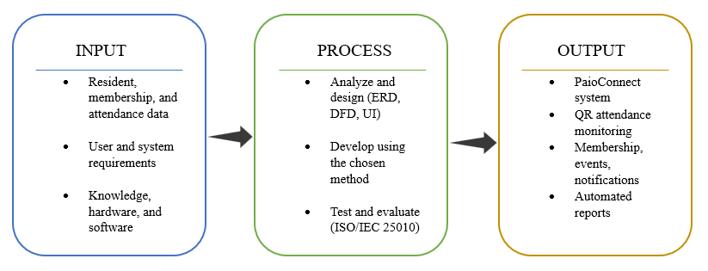

Figure 1. The Input-Process-Output (IPO) framework of the study
Input. The resources and information the study requires: resident, membership, attendance, event-budget, and barangay-inventory data; the functional and non-functional requirements gathered from Barangay Piao staff and residents, including their preferred interface language; and the knowledge, hardware, and software needed to build the system.
Process. The development activities: analyzing and designing the system — including the entity-relationship diagram, data flow diagrams, and interface designs for QR code generation, QR code scanning, resident management, membership management, event posting, event budget tracking, notification management, automated post-event feedback collection, barangay inventory management, and the Filipino/Tagalog–Bisaya–English interface — developing the system using the chosen methodology, and testing and evaluating it against the ISO/IEC 25010 quality characteristics of functionality, usability, reliability, security, and efficiency.
Output. The resulting PiaoConnect: Membership, Attendance, Event, and Resource Management System, a centralized, multilingual platform that automates attendance monitoring, membership tracking, event announcements and budgets, resident feedback collection, barangay inventory records, and report generation for Barangay Piao, Roxas, Zamboanga del Norte.
A feedback loop connects the output back to the process: results from testing and user acceptance evaluation are used to refine the system, consistent with the study's iterative development approach.

Synthesis of the Reviewed Literature and Systems
Across the reviewed literature and systems, a consistent pattern emerges: QR code technology is a proven, low-cost way to automate attendance; centralized, web-based databases have already replaced manual logbooks for barangay resident profiling and document issuance in several Philippine barangays; automated notification measurably improves how quickly members receive event information; multilingual access is a documented, unresolved gap in Philippine e-government platforms; and structured feedback surveys are beginning to appear in newer barangay and youth-council systems as a way to support project evaluation.
Yet no single reviewed system combines QR-based attendance monitoring with resident management, membership tracking, event posting, event budget tracking, notification management, automated post-event feedback, a multilingual interface, barangay inventory management, and printable reporting in one platform built specifically for barangay-level membership and assembly monitoring. This gap is summarized in Table 1.
Table 1 Comparative Matrix of the Reviewed Systems and PiaoConnect's Features
System | QCG | QCAS | RM | MM | EP | NM | AM | PR | ML | FB | BT | INV
QR Code-Based Attendance System for education settings [4] | ✓ | ✓ | ✗ | ✗ | ✗ | ✗ | ✓ | ✓ | ✗ | ✗ | ✗ | ✗
Web-Based Resident Information Management System [7] | ✓ | ✗ | ✓ | ✗ | ✗ | ✓ | ✗ | ✓ | ✗ | ✗ | ✗ | ✗
Web-Based Barangay Profiling and Issuance System [8] | ✗ | ✗ | ✓ | ✗ | ✗ | ✗ | ✗ | ✓ | ✗ | ✗ | ✗ | ✗
BarangayConnect Web-Based Information Portal [9] | ✗ | ✗ | ✓ | ✗ | ✗ | ✗ | ✗ | ✓ | ✗ | ✗ | ✗ | ✗
Event Management System with SMS Notification [10] | ✗ | ✗ | ✗ | ✗ | ✓ | ✓ | ✗ | ✗ | ✗ | ✗ | ✗ | ✗
Kabataan-Konek: Barangay Web-Based Youth Info. System [12] | ✓ | ✗ | ✓ | ✗ | ✗ | ✗ | ✗ | ✓ | ✗ | ✓ | ✗ | ✗
PiaoConnect (Proposed System) | ✓ | ✓ | ✓ | ✓ | ✓ | ✓ | ✓ | ✓ | ✓ | ✓ | ✓ | ✓

Legend:
✓ feature present in the reviewed system;
✗ feature absent (gap addressed by PiaoConnect).
Acronyms:
QCG → QR Code Generation
QCAS → QR Code Attendance Scanning
RM → Resident Management
MM → Membership Management
EP → Event Posting
NM → Notification Management
AM → Attendance Monitoring
PR → Printable Reports
ML → Multi-language Interface
FB → Automated Feedback
BT → Event Budget Tracking
INV → Barangay Inventory Management
As Table 1 shows, each existing system addresses only part of the problem: QR-based attendance systems handle scanning but not resident or membership data; barangay resident and profiling systems handle records but not attendance or events; the SMS-based event system handles notification but nothing else; and the most recent youth-council system adds structured feedback but not event-level attendance, budgeting, or a multilingual interface. PiaoConnect is positioned to fill this gap by combining QR code generation, QR code attendance scanning, resident management, membership management, event posting, event budget tracking, notification management, attendance monitoring, automated post-event feedback, a multilingual interface, barangay inventory management, and printable reports into a single centralized system built for Barangay Piao, Roxas, Zamboanga del Norte.

Annotated Bibliography
The following annotated bibliography lists each literature reviewed in IEEE citation style, together with its currency (years since publication, relative to 2026) and the specific research gap it leaves that PiaoConnect addresses.
[1] R. P. Bringula, M. A. D. Vale, J. A. Napolis, F. P. Oliva, and D. J. T. De La Serna, “E-Barangay: A framework for a web-based system for local communities and its usability,” Procedia Comput. Sci., vol. 197, pp. 573–580, 2022. Currency: 4 years (published 2022). This study proposed a web-based e-governance framework for local communities, evaluated for usability, to support record management and public announcements. Gap: the framework addresses general community record-keeping and usability at a conceptual level; it does not include QR-based attendance monitoring, membership-group tracking, or the event/notification module PiaoConnect implements.
[2] J. T. Aliling, B. B. Santa Ana, and K. T. Soberano, “Digitalizing governance: A transformation on the processes of one community in the Philippines,” Zenodo, 2025. Currency: less than 1 year (published 2025), the most recent source reviewed at the time it was added. This study examined how digitalizing administrative processes improved the efficiency, accessibility, and reliability of services in a Philippine community. Gap: the study evaluates governance digitalization at a general, process-transformation level and does not itself implement or evaluate a QR-based attendance mechanism, membership module, or event-notification feature.
[3] D. J. B. Agripa and S. F. Astillero, “Development of employee attendance and management system using quick response (QR) code in Sorsogon State University,” Eur. J. Educ. Stud., vol. 9, no. 7, pp. 345–361, 2022. Currency: 4 years (published 2022). This study automated employee attendance at a state university using QR code generation and scanning, reporting improved accuracy, speed, and reliability over manual sign-in sheets. Gap: the system is scoped to institutional employee attendance and does not extend to resident profiling, membership tracking, event posting, or notification management — the additional modules PiaoConnect provides for a barangay setting.
[4] S. Raut, P. Bhure, P. Bariye, A. Nandeshwar, and J. Adhikari, “QR code-based attendance system,” Int. Res. J. Modernization Eng. Technol. Sci., vol. 5, no. 6, pp. 425–429, Jun. 2023. Currency: 3 years (published 2023). This study developed a QR code generator, scanner, and database to automate classroom attendance, reporting improved cost, speed, and security over biometric and manual methods. Gap: the system is confined to attendance logging in an educational setting and includes no resident profiling, membership tracking, event posting, or notification features — the components PiaoConnect adds for a barangay context.
[5] S. Pati, S. Bhanja, A. Majumder, S. Sahu, S. Banerjee, and G. Sen, “A novel QR code based smart attendance tracking system,” in Proc. 2023 7th Int. Conf. Electron., Mater. Eng. Nano-Technol. (IEMENTech), 2023. Currency: 3 years (published 2023). This IEEE conference paper presented a QR-based smart attendance tracking mechanism to reduce the time and error associated with manual sign-in sheets. Gap: like similar QR studies, it treats attendance as a standalone function and does not integrate resident or membership records, so it cannot on its own manage a barangay's broader monitoring needs.
[6] F. Y. Chowdhury, “Implementation of attendance management system utilizing fingerprint, QR code, and GPS technology in educational institutions,” Int. J. Sci. Res. (IJSR), vol. 12, no. 9, pp. 2016–2019, 2023. Currency: 3 years (published 2023). This study combined fingerprint, QR code, and GPS verification to strengthen identity and location confirmation during attendance recording. Gap: the multimodal approach adds verification strength but still does not extend to membership management, event posting, or notification, and its added hardware/GPS requirement is heavier than what a barangay-level deployment needs.
[7] U. M. Melendres and K. M. Aranda, “Development and evaluation of a web-based resident information management system,” J. Comput. Softw. Program, vol. 1, no. 1, pp. 14–22, 2024. Currency: 2 years (published 2024). Using the Rapid Application Development model, this study built a resident information system evaluated favorably across six ISO/IEC 25010 criteria (mean ratings 3.42–3.62). Gap: the system centralizes resident profiles and document requests and uses QR codes only for account login, not for attendance; it does not track membership groups, post events, or monitor attendance at barangay activities.
[8] M. J. G. Ballaran, M. J. M. Donaire, R. M. Singzon, S. M. Naz, D. V. Tanael, and C. J. Centeno, “Development and evaluation of web-based barangay profiling and issuance system using regression analysis,” World J. Adv. Res. Rev., vol. 20, no. 3, pp. 060–072, 2023. Currency: 3 years (published 2023). This study centralized resident profiling and automated certificate and permit issuance, evaluated positively across ISO/IEC 25010 sub-characteristics (means of 4.71–4.79). Gap: the system's scope is profiling and document issuance; it does not include attendance monitoring, QR-based scanning, membership management, or event and notification features.
[9] J. V. Enaño, K. P. Natividad, D. R. Pantoja, F. C. D. Ebi, J. V. Bautista, and D. Cura, “BarangayConnect: A web-based information portal for resident data, administrative services, and community records using data analytics and linear regression algorithms,” Int. J. Res. Innov. Soc. Sci., vol. 9, no. 10, pp. 1485–1497, Nov. 2025. Currency: less than 1 year (published November 2025). BarangayConnect centralizes resident data, automates document requests, and uses regression analysis to forecast service demand, with an overall mean acceptability rating of 3.0 (Agree). Gap: despite its recency and predictive analytics component, the system still does not provide QR-based attendance scanning, membership tracking, or event/notification management.
[10] F. M. Reyes, M. A. Abdulgani, M. F. Aliuden, J. M. Mantikayan, T. S. Guiamalon, S. G. Dilna, H. A. Mohamad, and S. Z. D. Nawal, “Event management system with SMS notification for Mindanao People's Care Foundation, Inc.,” Psychol. Educ.: Multidiscip. J., vol. 3, no. 7, pp. 600–609, 2022. Currency: 4 years (published 2022). This system automated the sending of SMS event and meeting announcements to an organization's members, and was rated favorably (grand mean 3.94) for function and reliability, working even without an internet connection. Gap: the system notifies members of events but does not manage resident records, membership status, or attendance, so it cannot verify or monitor who actually attended the events it announces.
[11] G. P. Concepcion, “Language choice in Philippine government websites: Sociolinguistic issues and implications,” SUVANNABHUMI, vol. 13, no. 1, pp. 35–64, Jan. 2021. Currency: 5 years (published 2021). This study analyzed language use across 235 Philippine government websites and found English overwhelmingly dominant, with Filipino and regional languages such as Bisaya minimally used, mostly outside of core service transactions; it proposes a tripartite English-Filipino-regional-language approach to improve accessibility. Gap: the study examines existing government websites rather than proposing or evaluating a specific system; it provides the sociolinguistic rationale for, but not a working precedent of, the multilingual interface PiaoConnect implements.
[12] B. A. Anggoto, C. G. Gonzaga, T. J. S. Varona, and P. C. Encarnacion, “Kabataan-Konek: A barangay web-based youth information management system with data analytics,” Int. J. Sci. Appl. Inf. Technol., vol. 14, no. 3, pp. 27–30, May–Jun. 2025. Currency: less than 1 year (published 2025), the most recent source reviewed. This study developed a web-based youth information system for a Sangguniang Kabataan council that included survey tools for project monitoring and evaluation alongside QR-based clearance issuance, scoring a 95.63% average across ISO/IEC 25010 criteria. Gap: its QR code use is limited to clearance authentication rather than event attendance scanning, and it does not include a membership module, event budgeting, or a multilingual interface; it is, however, the closest precedent found for PiaoConnect's automated feedback module.

CHAPTER III
METHODOLOGY
This chapter presents the methodology used in developing PiaoConnect: An Integrated Web-Based Membership, Attendance, Event, and Resource Management System for Barangay Piao. It describes the overall project design, the development methodology adopted and its justification, the functional and non-functional requirements of the system, the analysis and design models produced during system design, the tools and technologies selected for implementation, and the plan for testing and evaluating the system.

Project Design
This study follows a developmental research design, in which a working information system is designed, constructed, and evaluated as the principal output of the project. Because the objective is to produce a functioning membership and attendance management system for Barangay Piao rather than to test a hypothesis, the methodology places emphasis on iterative design, continuous validation with barangay staff, and structured evaluation against recognized software quality criteria. The sections that follow present the development methodology, the specified requirements, the system design models, the technologies employed, and the testing and evaluation plan.

Development Methodology
PiaoConnect was developed using a prototyping approach within an iterative and incremental model [13]. This methodology was adopted because, at the outset of the study, the barangay staff of Barangay Piao could describe their manual attendance and membership problems clearly but could not fully specify every screen and report they would eventually need; showing them working prototypes of each module allowed their requirements to be progressively clarified and confirmed. Developing the system in small, functionally complete increments — resident and membership management first, followed by QR code attendance, event and notification management, and finally budget tracking, inventory, and feedback — also reduced risk for a small, still-learning student development team, since each increment could be corrected before the next was attempted. A purely sequential Waterfall model was considered but not adopted, since it assumes requirements are stable and complete before design begins and defers client feedback until late in development; this fit poorly with a barangay client that had not previously used a digital system and whose feature priorities were expected to shift once staff could see and use working screens. Figure 1 illustrates the five phases of the adopted methodology and the feedback loop that connects evaluation back into design for each increment.
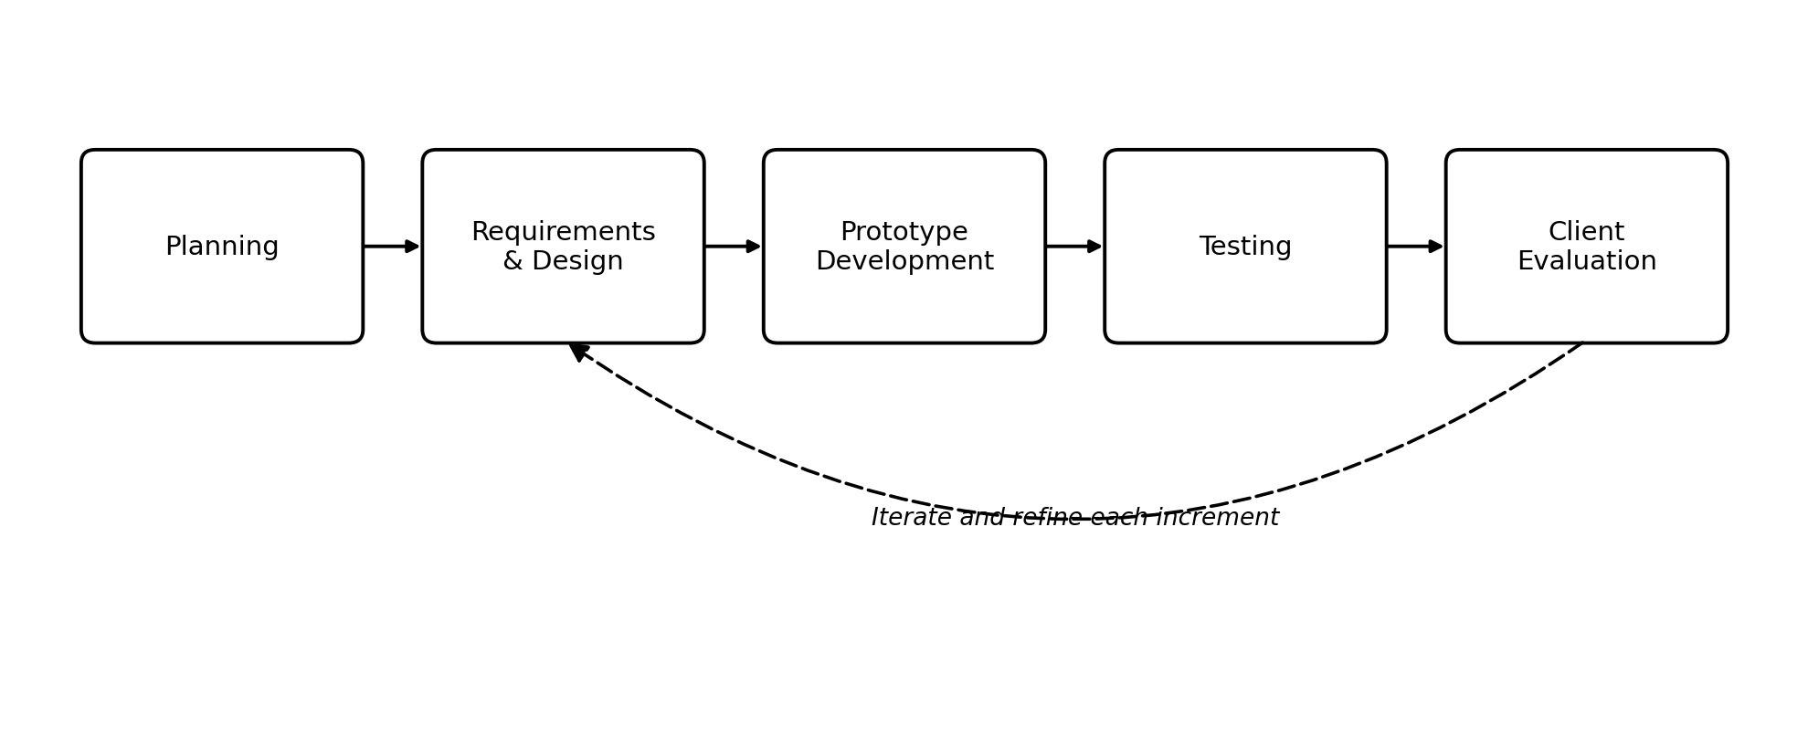
Figure 1. Prototyping approach within the iterative and incremental development model adopted for PiaoConnect.
Planning. The proponents, together with the capstone adviser and Barangay Piao staff, defined the scope of each increment, set a development schedule, and confirmed the priority of features based on the objectives identified in Chapter 1. Table 2 lists the increments in the order they will be built.

Table 1
Development Increments
Increment | Scope
1 | Resident and membership management: resident registration, profile management, membership groups, and account roles
2 | QR code attendance: QR code generation, member QR code display, and staff scanning of attendance at events
3 | Event and notification management: posting events, restricting events to membership groups, and automated in-app notifications
4 | Budget, inventory, and feedback: event budget and expense tracking, barangay inventory management, and automated post-event feedback
5 | Reporting and language support: printable attendance, membership, budget, and inventory reports, and multi-language interface support

Requirements and Design. For each increment, the team analyzed the affected processes and data, and produced or updated the process models, data model, and interface designs presented later in this chapter before any coding was undertaken.
Prototype Development. A working prototype of the increment — for example, the QR code generation and scanning module — was built and demonstrated to barangay staff and, where applicable, a small group of resident volunteers.
Testing. Each increment was tested against the functional and non-functional requirements it was meant to satisfy, to confirm that it behaved correctly before being shown to the client.
Client Evaluation. Feedback gathered from testing and from barangay staff was used to refine the increment before the next cycle began, as represented by the feedback loop in Figure 1. This cycle will continue through Capstone 2 until all the modules described in Chapter 1 have been implemented and evaluated.

System Requirements
The functional and non-functional requirements of PiaoConnect were derived from interviews with Barangay Piao staff, informal observation of the current manual attendance and membership process, and the objectives and scope established in Chapter 1. The functional requirements specify the tasks the system must perform; the non-functional requirements specify the quality attributes the system must exhibit while performing them. Table 3 presents the core functional requirements, each traceable to a specific objective of the study.
Table 2
Functional Requirements of PiaoConnect
ID | Functional Requirement
FR-1 | The system shall allow barangay staff to register, update, and search resident records.
FR-2 | The system shall allow barangay staff to create membership groups and assign residents to one or more memberships.
FR-3 | The system shall generate a unique QR code for each registered member.
FR-4 | The system shall allow barangay staff to scan a member's QR code to record attendance at an event.
FR-5 | The system shall allow barangay staff to post events with details such as date, time, location, and description.
FR-6 | The system shall send automated in-app notifications to members regarding posted events.
FR-7 | The system shall record and display attendance per member and per event for monitoring purposes.
FR-8 | The system shall allow barangay staff to generate printable attendance and membership reports.
FR-9 | The system shall allow barangay staff to record the approved budget and actual expenses of each event.
FR-10 | The system shall allow barangay staff to record and monitor barangay-owned inventory items, including quantity, condition, and location.
FR-11 | The system shall automatically send a short feedback survey to members after an event they attended.
FR-12 | The system shall allow users to switch the interface language among Filipino/Tagalog, Bisaya, and English.
FR-13 | The system shall require users to log in with valid credentials before accessing staff or member functions.

The non-functional requirements, summarized in Table 4, define the quality attributes the system must meet. Each is stated in measurable terms so that it can be verified during the evaluation described later in this chapter.
Table 3
Non-Functional Requirements of PiaoConnect
Category | Non-Functional Requirement
Performance | A QR-code attendance scan shall be recorded in under 3 seconds under normal network conditions.
Usability | Barangay staff and residents shall be able to perform common tasks (registration, attendance scanning, event posting) after no more than 30 minutes of orientation.
Reliability | The system shall remain available throughout the scheduled duration of a barangay event, with a target uptime of at least 99 percent.
Security | Access to staff functions shall be role-based, passwords shall be stored using industry-standard hashing, and personal data shall be handled in accordance with the Data Privacy Act of 2012 [15].
Efficiency/Scalability | The system shall support at least 5,000 registered residents and at least 300 concurrent attendance scans during peak assembly hours.

System Design
System design translates the requirements in Table 3 and Table 4 into concrete models. Process models describe how data moves between residents, staff, and the system; the data model describes how information about residents, memberships, events, attendance, budgets, and inventory is structured and stored; and the architecture and interface designs describe how the system is organized internally and how it will be operated by its two classes of users.
3.4.1 Process Models
The processes of PiaoConnect were modeled using a context diagram, a level-0 data flow diagram, and a use case diagram, each drawn using a single consistent notation. The context diagram in Figure 2 presents the system as a single process together with the external entities it exchanges data with — the resident/member and the barangay staff — and establishes the boundary of the study. Event notifications are generated and delivered entirely within the system itself, so no external notification service sits at the boundary of the study.
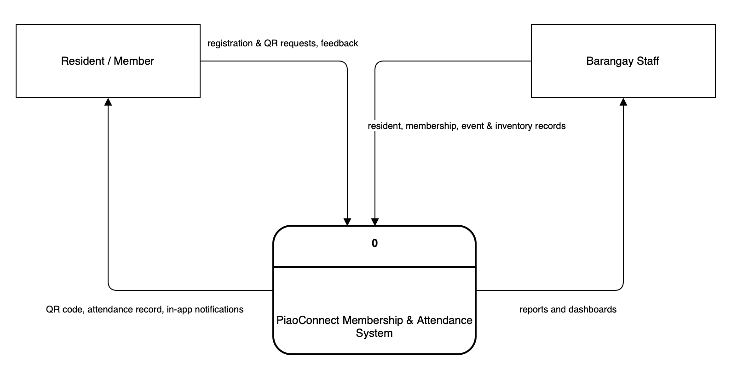
Figure 2. Context diagram of the proposed PiaoConnect system.
The context diagram was decomposed into the level-0 data flow diagram in Figure 3, which details the five major processes of the system — managing resident and membership records, generating and scanning QR codes for attendance, managing events and notifications, managing event budgets and barangay inventory, and generating reports and collecting feedback — together with the data stores each process reads from or writes to.

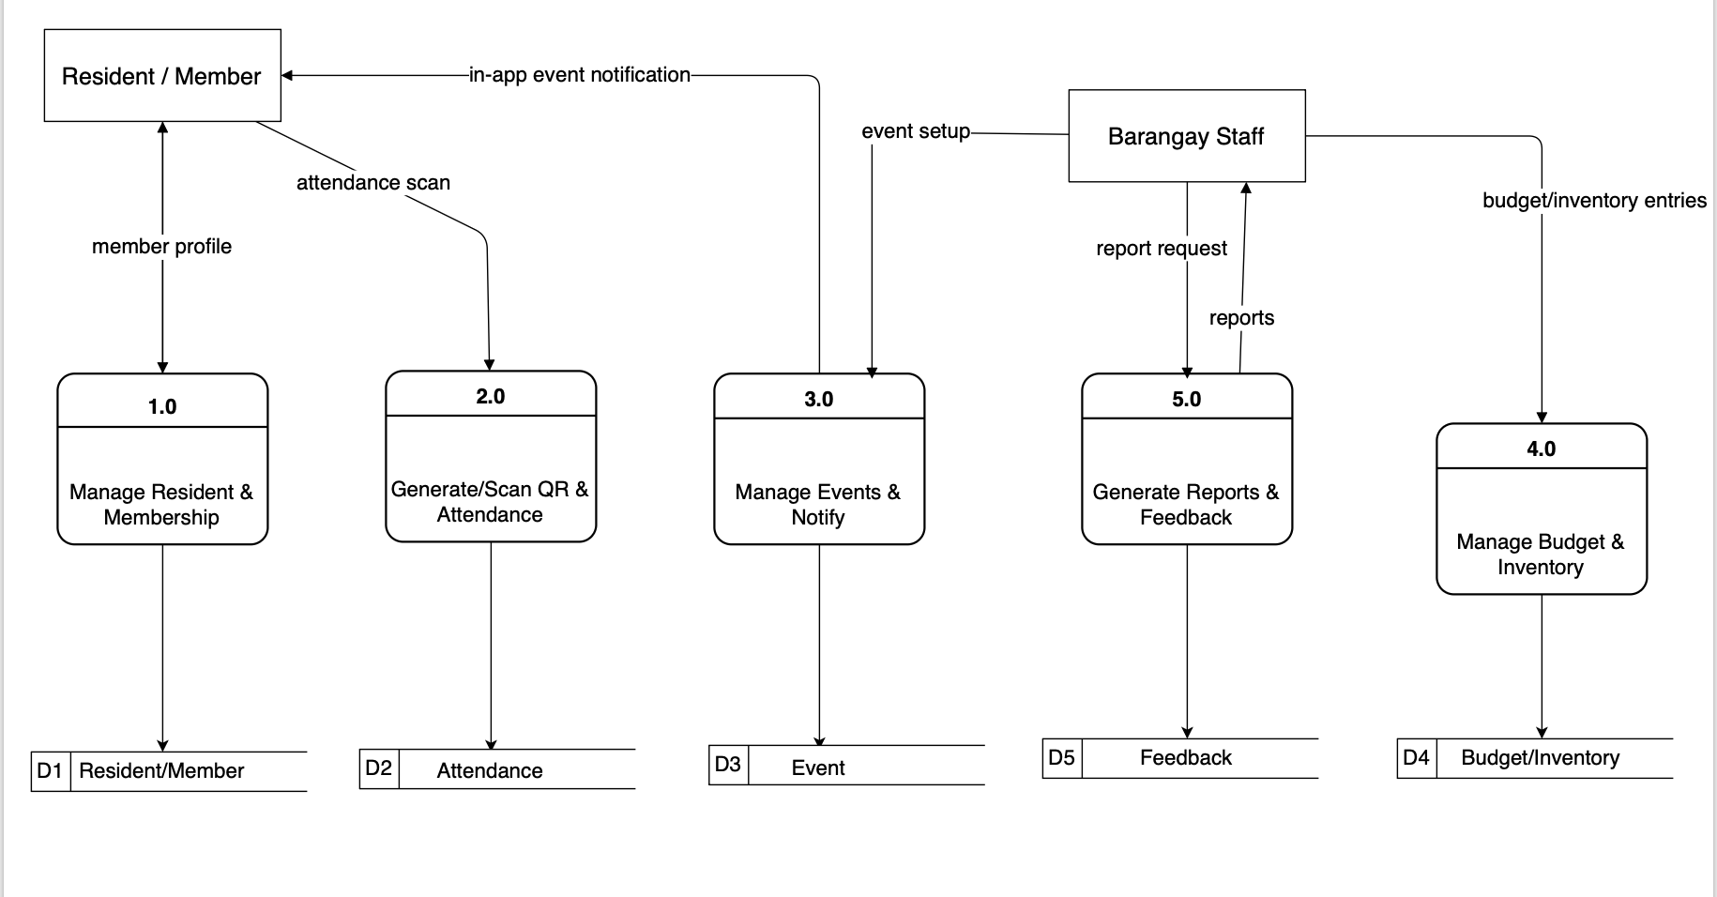
Figure 3. Level-0 data flow diagram of the proposed PiaoConnect system.

A use case diagram was also prepared to capture the goals of each actor, shown in Figure 4. The Resident/Member can manage their own profile, display their QR code, view their attendance history, receive notifications, submit post-event feedback, view posted events, and switch the interface language. The Barangay Staff can manage resident and membership records, generate QR codes, scan attendance, post events and trigger notifications, track event budgets, manage barangay inventory, generate printable reports, and likewise switch the interface language. QR code display and attendance scanning include the underlying QR-generation and QR-validation logic, as indicated by the include relationships in Figure 4.
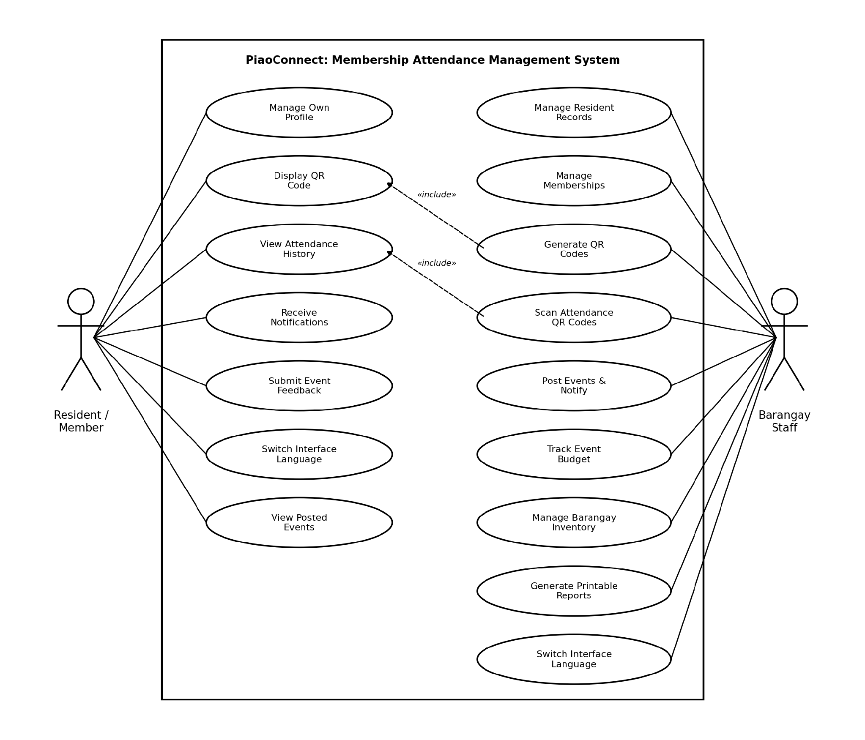
Figure 4. Use case diagram of the proposed PiaoConnect system.

3.4.2 Data Model
The data requirements of PiaoConnect were modeled as an entity-relationship diagram, shown in Figure 5. The central entity is users, which stores every resident and staff account and distinguishes the two through its role field; a resident becomes a system user directly, with household_id linking related residents through the households entity. A user may belong to one or more membership groups; this many-to-many relationship between users and memberships is resolved through the membership_residents junction entity. Membership eligibility rules reference three lookup entities, age_brackets, civil_statuses, and current_statuses, the last of which also participates in a many-to-many relationship with users through the current_status_user junction entity, recording a user's status history over time. The many-to-many relationship between users and events, expressed through participation in barangay activities, is resolved through the attendances junction entity, which records the time-in, time-out, and status of each scan. feedback and event_expenses are likewise modeled as dependent entities of events, capturing post-event ratings and comments and itemized expenses respectively, while event_inventory_items resolves the many-to-many relationship between events and inventory_items for equipment borrowed per event. notifications and sms_logs each depend on users and, optionally, on events. activity_logs records a textual, staff-readable audit trail keyed by user_code but is not enforced by a foreign key, and integration_settings is a standalone configuration entity with no relationship to the rest of the schema. Every entity has a designated primary key, and the model is normalized to the third normal form. Table 5 lists the entities and what each holds.
Table 4
Entities of the Data Model
Entity | Purpose
users | Every resident and barangay-staff account. A single table distinguished by its role field (Staff or Resident), linked to households and to civil_statuses, and flagged has_account to mark whether the person can log in.
households | A household unit at a shared address, referenced by member users through household_id; supports grouping residents who live together.
civil_statuses | Lookup table of civil-status labels (e.g., Single, Married), referenced by users and by membership eligibility rules.
age_brackets | Lookup table of age ranges used to define which users are eligible for a given membership.
current_statuses | Lookup table of status labels (e.g., active, relocated) a user can hold over time, tracked historically through current_status_user.
current_status_user | Junction entity resolving the many-to-many relationship between users and current_statuses, recording each status a user has held.
memberships | A defined membership group (for example, a Purok organization or the senior citizens' association) with optional eligibility rules based on age bracket, civil status, current status, and gender.
membership_residents | Junction entity resolving the many-to-many relationship between users and memberships.
events | A barangay activity, holding its schedule, location, description, approved budget, and the membership group(s) it is restricted to.
attendances | Junction entity resolving the many-to-many relationship between users and events, recording each user's time-in, time-out, and attendance status for an event.
event_expenses | An itemized expense charged against the approved budget of an event, including its supporting receipt file.
inventory_items | A barangay-owned asset, holding its quantity, condition, and storage location, maintained independently of any single event.
event_inventory_items | Junction entity resolving the many-to-many relationship between events and inventory_items, recording the quantity of each item borrowed for an event.
feedback | A user's post-event rating and comment, submitted in response to an automated survey after attending an event.
notifications | An in-app message delivered to a user regarding a posted event or another system event, with a read flag.
sms_logs | A record of an SMS notification sent or simulated for a user, optionally tied to an event, together with its delivery status.
activity_logs | A textual, staff-readable audit trail of actions performed in the system, keyed by user_code as an informal reference rather than an enforced foreign key.
integration_settings | Standalone configuration entity (key/value pairs) for external integrations, with no relationship to the other entities.
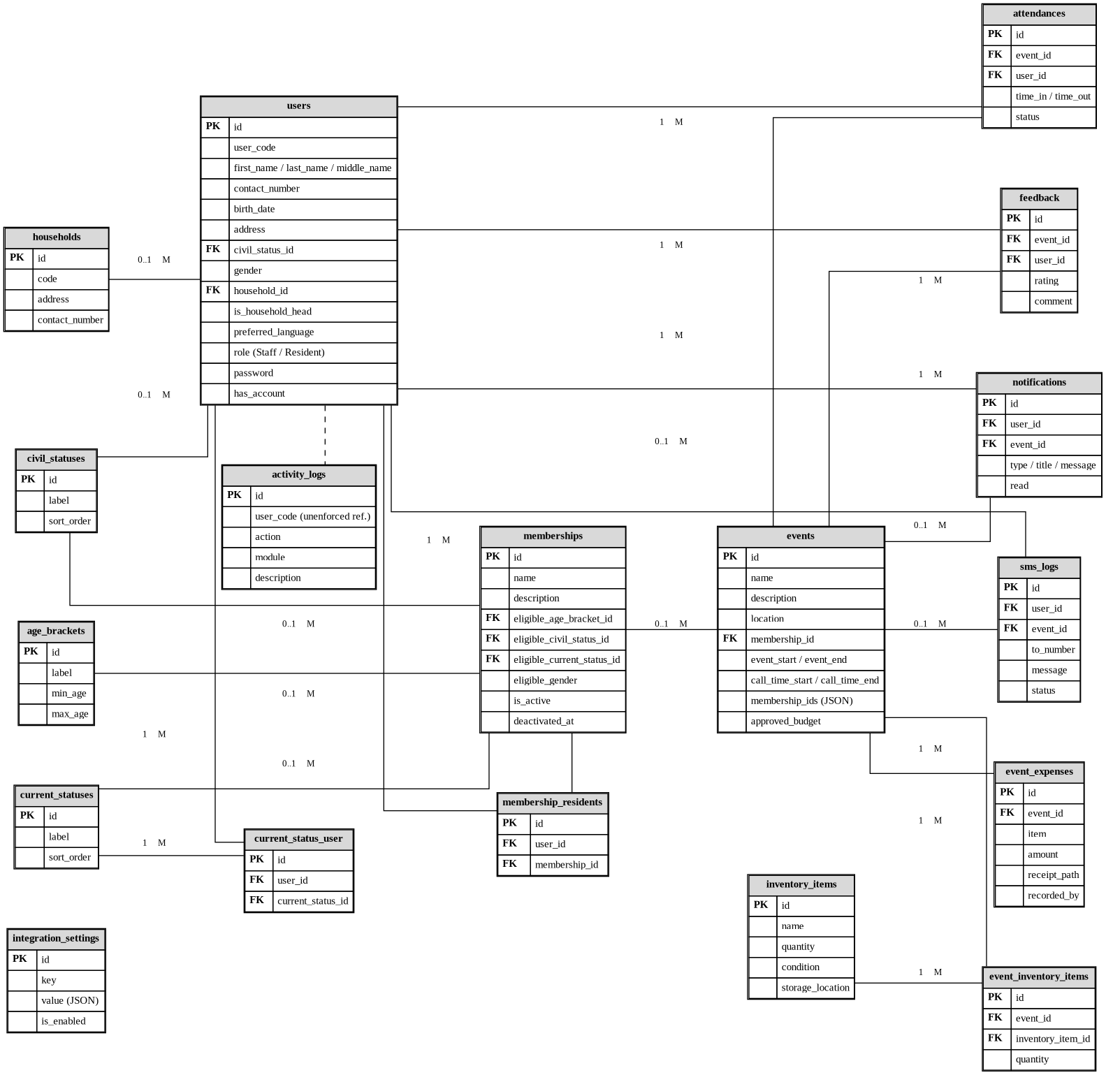

Figure 5. Entity-relationship diagram of the proposed PiaoConnect system.

Every field of every entity in Figure 5 will be documented in a complete data dictionary; Table 6 shows excerpts for the users and events entities as an example of the level of detail to be maintained for each table.
Table 5
Data Dictionary Excerpt — users
Field | Type | Size | Key | Description
id | BIGINT | — | PK | Unique identifier of a user account (resident or staff)
user_code | VARCHAR | 50 | — | Human-readable code assigned to the user (e.g., PR-0006), used in logs and QR payloads
civil_status_id | BIGINT | — | FK | References the user's civil status (lookup)
household_id | BIGINT | — | FK | References the household the user belongs to
role | ENUM | — | — | Account type: Staff or Resident

Table 6
Data Dictionary Excerpt — events
Field | Type | Size | Key | Description
id | BIGINT | — | PK | Unique identifier of a barangay event
name | VARCHAR | 255 | — | Short name of the event shown on the events list and notifications
event_start | DATETIME | — | — | Date and time the event begins
location | VARCHAR | 100 | — | Venue or place where the event is held
approved_budget | DECIMAL | 10,2 | — | Approved budget amount for the event, compared against recorded expenses
membership_id | BIGINT | — | FK | References the single membership group the event is restricted to, if any (nullable)

3.4.3 System Architecture and Interface Design
PiaoConnect follows a three-tier architecture, illustrated in Figure 6. The presentation tier is a responsive single-page web application, built with React and TypeScript and styled with Tailwind CSS, accessible through a desktop or mobile browser and rendered in English, Filipino/Tagalog, or Bisaya according to the user's preference; this is also the tier where a member's QR code is displayed on screen and where barangay staff scan a member's QR code using the device camera during an event. The application tier, built with the Laravel framework, contains the system's business logic — including validating a scanned QR code against the corresponding member record, computing event budgets and inventory updates, and generating reports — and exposes this logic to the frontend through a REST API. The data tier is a MySQL/MariaDB relational database that stores the resident, membership, attendance, event, budget, and inventory records defined in the data model. Separating the tiers in this way keeps the system maintainable and allows the presentation, logic, and storage layers to be developed, tested, and scaled independently. Event notifications and post-event feedback prompts are generated by the application tier and written directly to the database as they occur; residents see them the next time they open the web application, in an in-app notification center in the presentation tier, without relying on an external SMS or email service.
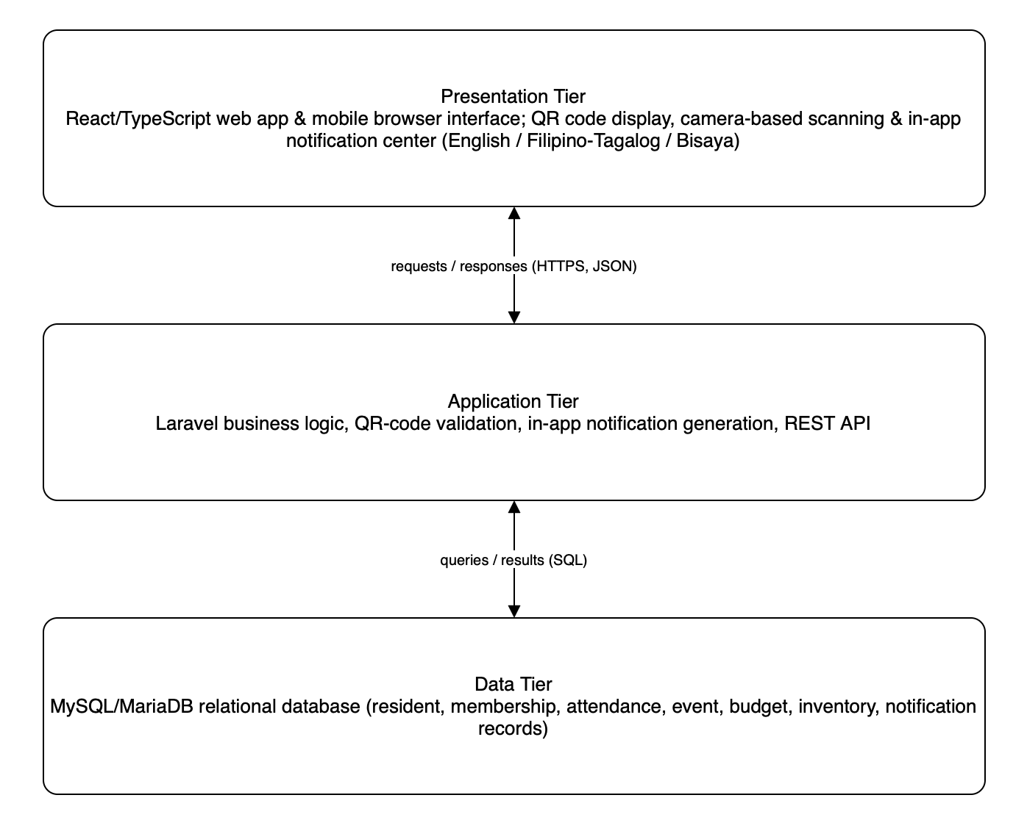
Figure 6. Three-tier architecture of the proposed PiaoConnect system.
The server-side code follows a layered structure, separating presentation concerns from business logic and data access. Table 8 sets out the division.
Table 7
Internal Structure of the Server-Side Solution
Component | Contents | Depends on
Models | Eloquent model classes for each entity (Resident, Member, MembershipType, Event, Attendance, Notification, Feedback, EventExpense, InventoryItem, UserAccount), including their relationships and query scopes | Database (migrations)
Requests | Form request classes that validate and authorize incoming data before it reaches a controller | Models
Services | Business logic classes, including QR-code generation and validation, attendance recording, budget computation, and report generation, kept independent of the HTTP layer | Models, Requests
Controllers | HTTP request handlers for each resource (residents, memberships, events, attendance, budgets, inventory, reports), delegating business logic to services and returning JSON responses | Requests, Services, Models
Routes / Middleware | REST route definitions grouped by resource, protected by role-based middleware distinguishing barangay staff from resident/member accounts | Controllers
Database (Migrations & Seeders) | Schema migrations, foreign key constraints, and seed data for the MySQL/MariaDB database | Nothing

The user interface was designed for use by barangay staff with limited technical background and by residents on ordinary mobile phones. Wireframes were prepared for the primary screens — staff login and dashboard, resident/member registration, QR code display, attendance scanning, event posting, budget and inventory entry, and the resident-facing event and feedback screens — together with a navigation flow that keeps common staff tasks, such as scanning attendance during an event, to as few steps as possible. The complete wireframes and navigation map will be included in the appendices.

Tools and Technologies
The technologies for PiaoConnect were selected for their fit to the requirements in Table 3 and Table 4, their cost — all of the core components are free or open source — and the ability of the student development team to learn and support them within the project timeline. Table 9 summarizes the selected technology stack.
Table 8
Technology Stack of PiaoConnect
Layer | Technology | Purpose
Frontend | React 19 with TypeScript, Tailwind CSS | Responsive, mobile-friendly user interface for staff and residents
Backend | Laravel 12 (PHP) | Business logic, routing, and REST API endpoints
Database | MySQL / MariaDB | Relational storage for residents, memberships, events, attendance, and notifications
QR code generation | qrcode.react | Generates a scannable QR code for each registered resident
QR code scanning | @yudiel/react-qr-scanner | Camera-based scanning of a resident's QR code during events
Build tool | Vite | Frontend bundling and hot-reload development server
Version control | Git and GitHub | Source code management and team collaboration

Use Case Narratives
This section presents the complete inventory of use cases for PiaoConnect and a fully-dressed narrative for each, following the format used to specify individual user goals and system responsibilities. Table 10 lists every use case together with its identifier, primary actor, and the functional requirement it satisfies.
Table 9
Use Case Inventory
ID | Use Case | Primary Actor | Requirements
UC-1 | Log In | Resident/Member, Barangay Staff | FR-13
UC-2 | Register Resident and Create Membership Account | Barangay Staff | FR-1
UC-3 | Manage Resident Records | Barangay Staff | FR-1
UC-4 | Manage Membership Groups | Barangay Staff | FR-2
UC-5 | Generate Member QR Code | Barangay Staff | FR-3
UC-6 | Scan Attendance | Barangay Staff | FR-4, FR-7
UC-7 | Post Event and Trigger Notifications | Barangay Staff | FR-5, FR-6
UC-8 | Record Event Budget and Expenses | Barangay Staff | FR-9
UC-9 | Manage Barangay Inventory | Barangay Staff | FR-10
UC-10 | Generate Printable Reports | Barangay Staff | FR-8
UC-11 | Manage Own Profile | Resident/Member | FR-1
UC-12 | Display QR Code | Resident/Member | FR-3
UC-13 | View Attendance History | Resident/Member | FR-7
UC-14 | View Posted Events | Resident/Member | FR-5
UC-15 | Receive Notifications | Resident/Member | FR-6
UC-16 | Submit Post-Event Feedback | Resident/Member | FR-11
UC-17 | Switch Interface Language | Resident/Member, Barangay Staff | FR-12
UC-18 | Log Out | Resident/Member, Barangay Staff | FR-13

Table 10
Use Case 1 Narrative: Log In (UC-1)
Log In (UC-1)
Scope | PiaoConnect: An Integrated Web-Based Membership, Attendance, Event, and Resource Management System for Barangay Piao
Level | User Goal
Goal in Context | Allow a registered resident, member, or barangay staff user to authenticate before accessing the functions of their role.
Primary Actor | Resident/Member, Barangay Staff
Stakeholders | Barangay Piao staff and residents who need assurance that only authorized users can view or change records.
Preconditions | The user already has an account created either by barangay staff (for a resident/member) or by an administrator (for a staff account).
Triggers | The user opens PiaoConnect and selects Log In.
Success Guarantee | The system authenticates the user, opens the dashboard appropriate to their role, and records the login event.
Main Success Scenario
1. The user opens PiaoConnect and selects Log In.
2. The system displays a login form asking for a username or resident ID and a password.
3. The user enters their credentials and submits the form.
4. The system verifies the credentials against the stored, hashed password.
5. The system determines the user's role (Barangay Staff or Resident/Member) and opens the corresponding dashboard.
Extensions
4a. The credentials do not match any account: the system states that the username or password is incorrect and allows another attempt.
4b. The account has been deactivated by an administrator: the system denies access and displays a message directing the user to contact barangay staff.

Table 11
Use Case 2 Narrative: Register Resident and Create Membership Account (UC-2)
Register Resident and Create Membership Account (UC-2)
Scope | PiaoConnect: An Integrated Web-Based Membership, Attendance, Event, and Resource Management System for Barangay Piao
Level | User Goal
Goal in Context | Allow barangay staff to add a new resident to the system and, where applicable, create the corresponding member account.
Primary Actor | Barangay Staff
Stakeholders | Barangay Piao staff, who need an accurate and searchable roll of residents; residents, whose basic information must be recorded correctly.
Preconditions | The resident is not yet registered in the system.
Triggers | Barangay staff selects Register Resident from the dashboard, typically during in-person registration at the barangay hall.
Success Guarantee | The system creates a resident record and, if a membership account is requested, a linked member account with a unique QR code.
Main Success Scenario
1. Barangay staff selects Register Resident.
2. The system displays a form asking for the resident's name, address (Purok), birth date, contact number, and household information.
3. Staff fills in the fields and indicates whether the resident should also be registered as a member.
4. The system validates the entries, checking that required fields are complete and that the resident is not already on record.
5. The system creates the resident record and, if requested, creates a linked member account with an initial active status.
6. The system generates a unique QR code for the new member account, consistent with UC-5.
Extensions
4a. A required field is empty or a contact number is malformed: the system marks the field and asks staff to correct it.
4b. A resident with matching name and birth date already exists: the system warns staff of the possible duplicate and asks for confirmation before proceeding.

Table 12
Use Case 3 Narrative: Manage Resident Records (UC-3)
Manage Resident Records (UC-3)
Scope | PiaoConnect: An Integrated Web-Based Membership, Attendance, Event, and Resource Management System for Barangay Piao
Level | User Goal
Goal in Context | Allow barangay staff to search, view, and update the stored information of an existing resident.
Primary Actor | Barangay Staff
Stakeholders | Barangay Piao staff, who rely on records staying current; residents, whose information should be corrected promptly when it changes.
Preconditions | The resident is already registered in the system.
Triggers | Barangay staff selects Resident Records from the dashboard and searches for a resident.
Success Guarantee | The requested resident record is displayed, and any changes staff make are saved and time-stamped.
Main Success Scenario
1. Barangay staff selects Resident Records and enters a name, Purok, or resident ID to search.
2. The system returns matching resident records.
3. Staff selects a resident to view the full profile.
4. Staff edits one or more fields, such as address, contact number, or household composition.
5. The system validates the changes and saves the updated record.
Extensions
2a. No resident matches the search terms: the system states that no record was found and offers to register a new resident.
4a. An edited field fails validation: the system marks the field and asks staff to correct it before saving.

Table 13
Use Case 4 Narrative: Manage Membership Groups (UC-4)
Manage Membership Groups (UC-4)
Scope | PiaoConnect: An Integrated Web-Based Membership, Attendance, Event, and Resource Management System for Barangay Piao
Level | User Goal
Goal in Context | Allow barangay staff to create membership groups and assign residents to one or more of them.
Primary Actor | Barangay Staff
Stakeholders | Barangay Piao staff, who organize residents into purok organizations and other groups; members, whose group assignments determine which events and communications apply to them.
Preconditions | Barangay staff is logged in with the appropriate role.
Triggers | Barangay staff selects Membership Groups from the dashboard.
Success Guarantee | The membership group is created, updated, or the member's group assignment is saved.
Main Success Scenario
1. Barangay staff selects Membership Groups.
2. The system displays the list of existing membership types (for example, a Purok organization or the senior citizens' association).
3. Staff selects Add Group and enters a name and description, or selects an existing group to manage its members.
4. Staff searches for and selects a member to add to the group.
5. The system records the assignment through the MemberMembership entity, allowing the same member to belong to more than one group.
Extensions
3a. Staff enters a group name that already exists: the system states that the group exists and asks for a different name.
4a. The selected member is already assigned to the group: the system informs staff and takes no further action.

Table 14
Use Case 5 Narrative: Generate Member QR Code (UC-5)
Generate Member QR Code (UC-5)
Scope | PiaoConnect: An Integrated Web-Based Membership, Attendance, Event, and Resource Management System for Barangay Piao
Level | Subfunction
Goal in Context | Produce a unique, scannable QR code for a member account so that the member can be identified quickly during attendance recording.
Primary Actor | Barangay Staff
Stakeholders | Barangay staff, who need a fast and reliable way to identify members at events; members, who benefit from not having to sign paper attendance sheets.
Preconditions | A member account exists and does not yet have a valid QR code, or an existing code must be reissued.
Triggers | The system reaches the QR-generation step of resident registration (UC-2), or staff selects Reissue QR Code for an existing member.
Success Guarantee | A unique encoded string is generated, stored against the member record, and rendered as a scannable QR code image.
Main Success Scenario
1. The system, or barangay staff acting on a member's behalf, initiates QR code generation for a member account.
2. The system generates a unique encoded string tied to the member's account identifier.
3. The system stores the encoded string in the member record.
4. The system renders the encoded string as a QR code image using the qrcode.react library.
5. The QR code becomes available for the member to view (UC-12) and for staff to scan at events (UC-6).
Extensions
2a. The generated string collides with an existing one: the system regenerates the string until a unique value is produced.
4a. Staff reissues a QR code for a member who lost access to their previous one: the system invalidates the old code before rendering the new one.

Table 15
Use Case 6 Narrative: Scan Attendance (UC-6)
Scan Attendance (UC-6)
Scope | PiaoConnect: An Integrated Web-Based Membership, Attendance, Event, and Resource Management System for Barangay Piao
Level | User Goal
Goal in Context | Allow barangay staff to record a member's attendance at a barangay event by scanning the member's QR code.
Primary Actor | Barangay Staff
Stakeholders | Barangay staff, who need attendance recorded quickly during events with many attendees; members, whose participation should be credited accurately.
Preconditions | The event has already been posted (UC-7), and the member holds a valid QR code (UC-5).
Triggers | Barangay staff selects Scan Attendance for an ongoing event.
Success Guarantee | An Attendance record is created linking the member to the event, with the scan time and method recorded.
Main Success Scenario
1. Barangay staff selects the event and chooses Scan Attendance.
2. The system activates the device camera using the QR scanning library.
3. Staff points the camera at the member's displayed QR code.
4. The system validates the scanned code against the member record and confirms the member is not already marked present for this event.
5. The system creates the Attendance record, storing the scan time and the scanning method used.
6. The system displays a confirmation with the member's name so staff can verify the correct person was scanned.
Extensions
4a. The scanned code does not match any member record: the system rejects the scan and asks staff to try again or search manually.
4b. The member has already been recorded present for this event: the system informs staff and does not create a duplicate record.

Table 16
Use Case 7 Narrative: Post Event and Trigger Notifications (UC-7)
Post Event and Trigger Notifications (UC-7)
Scope | PiaoConnect: An Integrated Web-Based Membership, Attendance, Event, and Resource Management System for Barangay Piao
Level | User Goal
Goal in Context | Allow barangay staff to publish details of an upcoming barangay activity and notify members automatically.
Primary Actor | Barangay Staff
Stakeholders | Barangay staff, who need to communicate schedules efficiently; members, who rely on timely notice of events that concern them.
Preconditions | Barangay staff is logged in with the appropriate role.
Triggers | Barangay staff selects Post Event from the dashboard.
Success Guarantee | The event is stored and visible to members, and an in-app notification is generated for each affected member.
Main Success Scenario
1. Barangay staff selects Post Event.
2. The system displays a form asking for the event title, date, time, location, and description.
3. Staff fills in the fields, optionally restricting the event to one or more membership groups, and submits the form.
4. The system validates the entries and creates the event record.
5. The system generates a Notification record for each member covered by the event.
6. Members see the new notification the next time they open PiaoConnect (UC-15) and can view the event on their events screen (UC-14).
Extensions
3a. A required field is empty or the event date is in the past: the system marks the field and asks staff to correct it.
5a. No members belong to the specified membership group: the system posts the event but records that no notifications were generated.

Table 17
Use Case 8 Narrative: Record Event Budget and Expenses (UC-8)
Record Event Budget and Expenses (UC-8)
Scope | PiaoConnect: An Integrated Web-Based Membership, Attendance, Event, and Resource Management System for Barangay Piao
Level | User Goal
Goal in Context | Allow barangay staff to record the approved budget for an event and log the actual expenses incurred.
Primary Actor | Barangay Staff
Stakeholders | Barangay staff, who are accountable for how event funds are spent; barangay officials, who review budget-versus-actual figures.
Preconditions | The event has already been posted (UC-7).
Triggers | Barangay staff selects Manage Budget for a specific event.
Success Guarantee | The approved budget is recorded, and each itemized expense is stored as an EventExpense linked to the event.
Main Success Scenario
1. Barangay staff selects an event and chooses Manage Budget.
2. The system displays a form asking for the approved budget amount.
3. Staff enters the approved budget and saves it.
4. Staff selects Add Expense and enters a description and amount for each item purchased or paid for.
5. The system stores each entry as an EventExpense record linked to the event and updates the running total of actual expenses.
Extensions
3a. The entered budget is negative or not a number: the system rejects the value and asks for a valid amount.
5a. The running total of expenses exceeds the approved budget: the system still saves the entry but flags the event as over budget.

Table 18
Use Case 9 Narrative: Manage Barangay Inventory (UC-9)
Manage Barangay Inventory (UC-9)
Scope | PiaoConnect: An Integrated Web-Based Membership, Attendance, Event, and Resource Management System for Barangay Piao
Level | User Goal
Goal in Context | Allow barangay staff to record and monitor barangay-owned items, including their quantity, condition, and storage location.
Primary Actor | Barangay Staff
Stakeholders | Barangay staff, who are responsible for barangay property and need to know what is available and where it is kept.
Preconditions | Barangay staff is logged in with the appropriate role.
Triggers | Barangay staff selects Inventory from the dashboard.
Success Guarantee | The InventoryItem record is created or updated to reflect the current quantity, condition, and location.
Main Success Scenario
1. Barangay staff selects Inventory.
2. The system displays the current list of barangay-owned items.
3. Staff selects Add Item, or selects an existing item to update it.
4. Staff enters or edits the item name, quantity, condition, and storage location.
5. The system validates the entries and saves the InventoryItem record.
Extensions
4a. The quantity entered is negative: the system rejects the value and asks for a valid quantity.
5a. The item was previously marked as disposed or lost: the system asks staff to confirm before reactivating it.

Table 19
Use Case 10 Narrative: Generate Printable Reports (UC-10)
Generate Printable Reports (UC-10)
Scope | PiaoConnect: An Integrated Web-Based Membership, Attendance, Event, and Resource Management System for Barangay Piao
Level | User Goal
Goal in Context | Allow barangay staff to generate a printable report summarizing attendance, membership, budget, or inventory records.
Primary Actor | Barangay Staff
Stakeholders | Barangay staff and officials, who need summarized records for meetings, audits, and submissions to higher offices.
Preconditions | The underlying attendance, membership, budget, or inventory records already exist.
Triggers | Barangay staff selects Generate Report from the dashboard.
Success Guarantee | The system produces a formatted, printable report reflecting the requested records and date range.
Main Success Scenario
1. Barangay staff selects Generate Report.
2. The system asks staff to choose a report type (attendance, membership, budget, or inventory) and a date range or event.
3. Staff confirms the selection.
4. The system compiles the relevant records into a formatted report.
5. The system displays the report and offers options to print or save it as a PDF.
Extensions
4a. No records exist for the selected type and range: the system states that no data is available for the report.

Table 20
Use Case 11 Narrative: Manage Own Profile (UC-11)
Manage Own Profile (UC-11)
Scope | PiaoConnect: An Integrated Web-Based Membership, Attendance, Event, and Resource Management System for Barangay Piao
Level | User Goal
Goal in Context | Allow a resident or member to view and update their own profile information.
Primary Actor | Resident/Member
Stakeholders | Residents and members, who want their contact information kept current without visiting the barangay hall for minor updates.
Preconditions | The user is logged in as a resident or member.
Triggers | The user selects My Profile from the dashboard.
Success Guarantee | The system saves the updated profile information to the resident or member record.
Main Success Scenario
1. The user selects My Profile.
2. The system displays the user's current profile information.
3. The user edits fields such as contact number or preferred interface language.
4. The system validates the entries and saves the changes.
Extensions
3a. An edited field fails validation, such as a malformed contact number: the system marks the field and asks the user to correct it.

Table 21
Use Case 12 Narrative: Display QR Code (UC-12)
Display QR Code (UC-12)
Scope | PiaoConnect: An Integrated Web-Based Membership, Attendance, Event, and Resource Management System for Barangay Piao
Level | User Goal
Goal in Context | Allow a member to display their own QR code on their device so that barangay staff can scan it during an event.
Primary Actor | Resident/Member
Stakeholders | Members, who need quick, reliable access to their QR code at events.
Preconditions | The member's account already has a QR code generated (UC-5).
Triggers | The member selects My QR Code from the dashboard.
Success Guarantee | The member's QR code is rendered clearly on screen at a size that can be scanned by barangay staff.
Main Success Scenario
1. The member selects My QR Code.
2. The system retrieves the stored, encoded string for the member's account.
3. The system renders the QR code image on screen at a size suitable for scanning.
Extensions
2a. The member's account has no QR code on record: the system states that a code has not yet been issued and directs the member to barangay staff.

Table 22
Use Case 13 Narrative: View Attendance History (UC-13)
View Attendance History (UC-13)
Scope | PiaoConnect: An Integrated Web-Based Membership, Attendance, Event, and Resource Management System for Barangay Piao
Level | User Goal
Goal in Context | Allow a member to review the events they have attended and their recorded attendance times.
Primary Actor | Resident/Member
Stakeholders | Members, who want to confirm that their participation has been recorded correctly.
Preconditions | The member has attended at least one event, or is checking that no attendance has yet been recorded.
Triggers | The member selects My Attendance from the dashboard.
Success Guarantee | The system displays a list of the member's recorded attendance, most recent first.
Main Success Scenario
1. The member selects My Attendance.
2. The system retrieves the Attendance records linked to the member's account.
3. The system displays each attended event with its date and the recorded scan time.
Extensions
2a. No attendance records exist for the member: the system states that no attendance has been recorded yet.

Table 23
Use Case 14 Narrative: View Posted Events (UC-14)
View Posted Events (UC-14)
Scope | PiaoConnect: An Integrated Web-Based Membership, Attendance, Event, and Resource Management System for Barangay Piao
Level | User Goal
Goal in Context | Allow a resident or member to browse upcoming and past barangay events.
Primary Actor | Resident/Member
Stakeholders | Residents and members, who want to know what activities are scheduled and whether they concern their membership group.
Preconditions | At least one event has been posted (UC-7).
Triggers | The user selects Events from the dashboard.
Success Guarantee | The system displays the events applicable to the user, in chronological order.
Main Success Scenario
1. The user selects Events.
2. The system retrieves events that are either open to all residents or restricted to a membership group the user belongs to.
3. The system displays the events with their date, time, location, and description.
4. The user selects an event to view its full details.
Extensions
2a. No events are currently posted: the system states that there are no events to display.

Table 24
Use Case 15 Narrative: Receive Notifications (UC-15)
Receive Notifications (UC-15)
Scope | PiaoConnect: An Integrated Web-Based Membership, Attendance, Event, and Resource Management System for Barangay Piao
Level | User Goal
Goal in Context | Allow a resident or member to view in-app notifications generated by the system, such as new events or feedback requests.
Primary Actor | Resident/Member
Stakeholders | Residents and members, who need a single place to see announcements without relying on external SMS or email.
Preconditions | At least one notification has been generated for the user (for example, through UC-7 or UC-16).
Triggers | The user selects the notification icon from the dashboard.
Success Guarantee | The system displays the user's notifications and marks viewed notifications as read.
Main Success Scenario
1. The user selects the notification icon.
2. The system retrieves the Notification records linked to the user's account.
3. The system displays each notification with its type and the event or item it refers to.
4. The user selects a notification to open the related event or feedback prompt.
5. The system marks the opened notification as read.
Extensions
2a. No notifications exist for the user: the system states that there are no new notifications.

Table 25
Use Case 16 Narrative: Submit Post-Event Feedback (UC-16)
Submit Post-Event Feedback (UC-16)
Scope | PiaoConnect: An Integrated Web-Based Membership, Attendance, Event, and Resource Management System for Barangay Piao
Level | User Goal
Goal in Context | Allow a member to rate and comment on an event they attended, in response to an automated feedback prompt.
Primary Actor | Resident/Member
Stakeholders | Members, whose opinions help barangay staff improve future events; barangay staff, who use the feedback to plan.
Preconditions | The member attended the event, and the system has generated a post-event feedback notification (FR-11).
Triggers | The member opens the feedback notification for an attended event.
Success Guarantee | The system stores the member's rating and comment as a Feedback record linked to the event.
Main Success Scenario
1. The member opens the feedback notification for an attended event.
2. The system displays a short survey asking for a rating and an optional comment.
3. The member submits the rating and comment.
4. The system validates the submission and stores it as a Feedback record linked to the event and the member.
5. The system marks the feedback prompt as completed so it is not shown again for that event.
Extensions
3a. The member submits the form without selecting a rating: the system asks for a rating before accepting the submission.

Table 26
Use Case 17 Narrative: Switch Interface Language (UC-17)
Switch Interface Language (UC-17)
Scope | PiaoConnect: An Integrated Web-Based Membership, Attendance, Event, and Resource Management System for Barangay Piao
Level | User Goal
Goal in Context | Allow a resident, member, or barangay staff user to change the language the interface is displayed in.
Primary Actor | Resident/Member, Barangay Staff
Stakeholders | Residents, members, and staff who are more comfortable using the system in Filipino/Tagalog, Bisaya, or English.
Preconditions | The user is logged in, or is viewing a public screen that offers a language selector.
Triggers | The user selects the language option from the navigation bar.
Success Guarantee | The interface text is re-rendered in the selected language, and the preference is saved for the user's future sessions.
Main Success Scenario
1. The user selects the language option from the navigation bar.
2. The system displays the available languages: Filipino/Tagalog, Bisaya, and English.
3. The user selects a language.
4. The system re-renders the current screen in the selected language.
5. The system saves the selected language as the user's preference for future sessions.
Extensions
5a. The user is not logged in: the system applies the selected language for the current session only, without saving a preference.
Table 27
Use Case 18 Narrative: Log Out (UC-18)
Log Out (UC-18)
Scope | PiaoConnect: An Integrated Web-Based Membership, Attendance, Event, and Resource Management System for Barangay Piao
Level | User Goal
Goal in Context | Allow a resident/member or barangay staff user to end their authenticated session so the account cannot be used by anyone else on that device.
Primary Actor | Resident/Member, Barangay Staff
Stakeholders | Residents, members, and staff who share devices or use shared computers at the barangay hall and need assurance that ending a session actually revokes access.
Preconditions | The user is currently logged in (UC-1).
Triggers | The user selects Log Out from the navigation menu.
Success Guarantee | The system invalidates the current session and returns the user to the Log In screen.
Main Success Scenario
1. The user selects Log Out from the navigation menu.
2. The system invalidates the current authentication session.
3. The system redirects the user to the Log In screen (UC-1).
Extensions
2a. The session has already expired when Log Out is selected: the system discards any remaining session data and displays the Log In screen without error.

Testing and Evaluation Plan
The system will be tested and evaluated during the implementation phase in Capstone 2. Testing will proceed from unit testing of individual modules — such as QR code generation and validation, attendance recording, and budget computation — to integration testing across modules, and finally to user acceptance testing with Barangay Piao staff and a sample of resident volunteers. Consistent with the evaluation criteria stated in the objectives of this study, the quality of PiaoConnect will be assessed against five characteristics of the ISO/IEC 25010 software quality model [14]: functionality, usability, reliability, security, and efficiency — the same evaluation approach used in several of the reviewed related systems [7], [8], [12]. A structured evaluation instrument based on these five characteristics will be administered to barangay staff and resident respondents using a Likert-type scale; their ratings will be summarized and interpreted to determine whether PiaoConnect meets its acceptance criteria before it is turned over to Barangay Piao.

References
[1] R. P. Bringula, M. A. D. Vale, J. A. Napolis, F. P. Oliva, and D. J. T. De La Serna, “E-Barangay: A framework for a web-based system for local communities and its usability,” Procedia Computer Science, vol. 197, pp. 573–580, 2022.

[2] J. T. Aliling, B. B. Santa Ana, and K. T. Soberano, “Digitalizing governance: A transformation on the processes of one community in the Philippines,” Zenodo, 2025.

[3] D. J. B. Agripa and S. F. Astillero, “Development of employee attendance and management system using quick response (QR) code in Sorsogon State University,” European Journal of Education Studies, vol. 9, no. 7, pp. 345–361, 2022.

[4] S. Raut, P. Bhure, P. Bariye, A. Nandeshwar, and J. Adhikari, “QR code-based attendance system,” International Research Journal of Modernization in Engineering Technology and Science, vol. 5, no. 6, pp. 425–429, Jun. 2023.

[5] S. Pati, S. Bhanja, A. Majumder, S. Sahu, S. Banerjee, and G. Sen, “A novel QR code-based smart attendance tracking system,” in Proc. 2023 7th Int. Conf. Electronics, Materials Engineering and Nano-Technology (IEMENTech), 2023.

[6] F. Y. Chowdhury, “Implementation of attendance management system utilizing fingerprint, QR code, and GPS technology in educational institutions,” International Journal of Scientific Research (IJSR), vol. 12, no. 9, pp. 2016–2019, 2023.

[7] U. M. Melendres and K. M. Aranda, “Development and evaluation of a web-based resident information management system,” Journal of Computer Software Programming, vol. 1, no. 1, pp. 14–22, 2024.

[8] M. J. G. Ballaran, M. J. M. Donaire, R. M. Singzon, S. M. Naz, D. V. Tanael, and C. J. Centeno, “Development and evaluation of web-based barangay profiling and issuance system using regression analysis,” World Journal of Advanced Research and Review, vol. 20, no. 3, pp. 60–72, 2023.

[9] J. V. Enaño, K. P. Natividad, D. R. Pantoja, F. C. D. Ebi, J. V. Bautista, and D. Cura, “BarangayConnect: A web-based information portal for resident data, administrative services, and community records using data analytics and linear regression algorithms,” International Journal of Research and Innovation in Social Science, vol. 9, no. 10, pp. 1485–1497, Nov. 2025.

[10] F. M. Reyes, M. A. Abdulgani, M. F. Aliuden, J. M. Mantikayan, T. S. Guiamalon, S. G. Dilna, H. A. Mohamad, and S. Z. D. Nawal, “Event management system with SMS notification for Mindanao People's Care Foundation, Inc.,” Psychology and Education: Multidisciplinary Journal, vol. 3, no. 7, pp. 600–609, 2022.

[11] G. P. Concepcion, “Language choice in Philippine government websites: Sociolinguistic issues and implications,” SUVANNABHUMI, vol. 13, no. 1, pp. 35–64, Jan. 2021.

[12] B. A. Anggoto, C. G. Gonzaga, T. J. S. Varona, and P. C. Encarnacion, “Kabataan-Konek: A barangay web-based youth information management system with data analytics,” International Journal of Science and Applied Information Technology, vol. 14, no. 3, pp. 27–30, May–Jun. 2025.

[13] I. Sommerville, Software Engineering, 10th ed. Boston, MA, USA: Pearson, 2016.

[14] International Organization for Standardization, ISO/IEC 25010:2011 — Systems and Software Engineering — Systems and Software Quality Requirements and Evaluation (SQuaRE) — System and Software Quality Models, ISO/IEC, Geneva, Switzerland, 2011.

[15] Congress of the Philippines, Data Privacy Act of 2012, Republic Act No. 10173. Manila, Philippines, 2012.

